Drury Court Hotel
28-30 Lower Stephen's St.
Dublin City
Tel: +353 1 475 1988

The Drury Court is a modern 3-star Hotel, located in the heart of Dublin’s city centre. The hotel is located close to Grafton Street and St Stephens Green and allows the visitor easy access to the city’s many great tourist attractions. The accommodation consisting of 42 ensuite bedrooms. Each bedroom has a comfortable and contemporary design and are arranged to meet all the expectations of our guests, business and pleasure alike. Each well appointed room has a spacious and airy feel. Every bedroom offers the visitor sufficient space to allow the guest to work at a writing desk for work or writing postcards. Each room has direct dial telephone, computer/fax points, individually controlled central heating, multichannel remote controlled TV along with the provision of hairdryers, trouser-presses, laundering service and tea/coffee making facilities. Some rooms have air conditioning. Room Service is also available.
For added convenience complimentary WI-Fi is available in all bedrooms and public areas to all our guests.

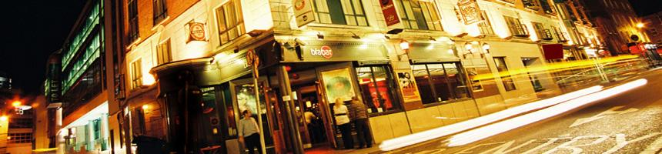
The lobby is fairly small, with a reception desk, a seating area, a lift and a staircase leading to the rooms.
Adjoining this 3 star hotel is the stylish and modern Bia Bar, with a wide selection of beverages and a restaurant style menu.
Some other hotel facilities include:
•Baby sitting
•Car rental facilities
•Disabled facilities
•Laundry facilities
•Lifts
•Lobby
•Room Service
•Free WIFI
 

